FEBRUARY 26 – MARCH 9 DOLLAR DRIVE

The Spiritridge Panther Leadership Service Committee is sponsoring the Dollar Drive to raise money for the Red Cross. The Red Cross is an organization that helps people who have undergone natural disasters and personal tragedies such as home fires.* Please donate and help us raise money.
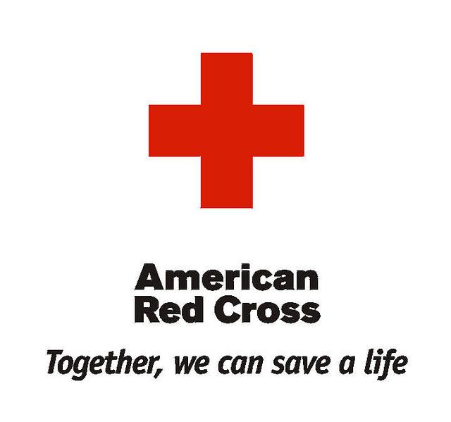

Raise money to help families in need.

────

The class that raises the most money earns a surprise!

Make sure to donate money! Put it in your classroom folder!

RED CROSS

www.redcross.org

SPONSORED BY: PLC

Panther Leadership Club

*Even though more people hear about large disasters like wildfires and floods, the biggest disaster threat in the United States is home fires. Through the Red Cross Home Fire Campaign, we’ve been able to make a difference.

